Can Machines Recognize Gender Fairly? A CNN Study on Bias and Representation
By Calef Alesse & Raneem Rahman
CPSC 390 Fall 2025

Introduction
Artificial Intelligence has become prominent in everyday life, especially through facial analysis technologies used in security screening, social media filters, device unlocking, and digital identity verification. As these systems become more common across both online and physical environments, concerns about their accuracy and fairness have grown. One of the most widely used tasks within facial analysis is gender classification, which forces faces into a binary category: male or female. However, gender is not binary, and reducing it to two labels raises important questions about who these systems are designed to recognize, and who they fail to represent.
At the same time, facial recognition has been known to produce uneven results across different groups. Ongoing concerns highlight the need to examine how models learn from the data they are trained on, and whether certain identities are treated as “default” while others are misrepresented or overlooked. Understanding these patterns is especially important when facial analysis systems are used to make decisions that affect people’s safety or access to services.
Given these issues, our project focuses on the question: Does a convolutional neural network (CNN) trained on the Kaggle Male/Female Faces dataset demonstrate bias? By analyzing its predictions and identifying patterns in misclassification, we aim to determine whether bias can show up even in small academic datasets and what that might reveal about bigger concerns surrounding fairness in facial analysis systems.

Background
Research on facial recognition consistently shows that these systems do not perform equally across all groups. The American Civil Liberties Union (ACLU) of Minnesota explains that facial recognition is “least reliable for people of color, women, and nonbinary individuals,” and that the technology often mirrors existing social inequalities rather than working fairly for everyone (Fergus, 2024). These problems can have serious consequences, especially when misidentifications lead to increased surveillance or false arrests. The ACLU argues that these systems can automatically reproduce discrimination because they are built on biased data and used within institutions that already treat different communities unequally.
The MIT “Gender Shades” study provides one of the clearest examples of how this bias shows up in actual models. According to MIT News, commercial gender-classification programs were extremely accurate for light-skinned men with error rates under 1%, but far less accurate for dark-skinned women, with error rates rising above 34% (Hardesty, 2018). These large gaps occur because many training datasets include far more images of lighter-skinned and male faces, so the models learn patterns that favor those groups while misrepresenting others.
These findings show how models often take “shortcuts” when the data they learn from lacks diversity. Instead of learning general features that work for everyone, models may end up relying on lighting conditions, image quality, or other cues that happen to appear more often in certain groups. When a dataset is unbalanced, the system becomes very good at classifying the groups it sees the most and significantly worse at recognizing everyone else. Both articles highlight that fairness problems begin with representation: if the data does not reflect the full range of human faces, the model will not be fair.
Our project addresses this gap by testing whether a CNN trained on the Kaggle Male/Female Faces dataset also shows performance differences across groups. If it does, it would suggest that bias can appear even in simple classroom datasets, reflecting the same structural problems seen in larger real-world systems.

Dataset Overview
The Kaggle dataset we used spanned over 5,418 images, covering multiple ethnicities and age groups. There are 2,698 images in the female class, and 2,720 images in the male class, making the dataset fairly even. The images were originally sourced from Bing and were collected through web scraping. While there is no formal metadata on the site, the author describes that 12-13% of the data depicts older people in both subfolders (Gupta, 2020). Through visual observation, many of the images shared similar characteristics, including very bright lighting, while others featured a variety of black & white images, as well as side profiles and other angled poses.
Considering potential embedded bias, we noticed the female class primarily consisted of women with long hair, makeup, and conventionally feminine features. On the other hand, the male class largely consisted of images of men with short hair and traditionally masculine facial features. This poses a risk that the model will learn to classify male/female based on secondary characteristics like hair length and makeup usage, rather than actual facial features.
There is also a considerable lack of diversity, with both datasets having limited representation of different demographics. While they are not completely omitted from the dataset, there is an underrepresentation of darker skin tones in comparison to the number of Western or lighter skin tones. There is also little to no representation of individuals with more ambiguous or non-stereotypical gender presentation. These visual patterns may influence model learning, and lead the model to perform well on the dominant group’s features but poorly on those who fall in the underrepresented demographics, potentially reinforcing existing biases in gender classification systems.

Methods
The purpose of our convolutional neural network (CNN) model was to investigate how bias can manifest in image classification. Our aim was to use this project as a “case study” of sorts and observe how a simple CNN behaves when trained on real-world data containing natural imbalances in appearance, race, and presentation.
Data preprocessing included resizing the images to 150 x 150 and grouping them into batches of 32. Then, the dataset was split into training and testing sets (80/20 split), and both sets were shuffled to prevent the model from learning based on order patterns. Finally, we scaled the pixels (image/255) for value normalization. Additionally, we applied caching and autotune prefetching to speed up the epoch training time.
The CNN architecture consisted of three convolutional layers with ReLU activation and max-pooling after each. A 50-unit dense layer followed the flattening step, and a final sigmoid output was used for binary classification between male and female classes. The model was trained using binary cross-entropy loss and the Adam optimizer (tested with learning rates of 0.01 and 0.001). The model was trained with 4 epochs and a batch size of 32. We attempted to increase the number of epochs, but the high image resolution and dataset size resulted in each epoch taking more than 15 minutes. We applied caching and autotuning in an attempt to speed up the process, but unfortunately did not see extensive improvement (Khan, 2024). Therefore, we chose 4 epochs, which took around 40 minutes in total to train, and still produced consistently proficient metrics.
After training, the model was evaluated on overall accuracy (the proportion of all classifications that were correct, both negative and positive), precision (the proportion of all the model’s classifications that are actually positive), recall (the proportion of all actual positives that were correctly classified), and an F1score (harmonic mean of precision and recall) (Google, 2024). The performance was also visualized through a confusion matrix, showing true positives, true negatives, false positives, and false negatives. The final analysis conducted includes evaluating performance differences and model accuracy at learning rates of 0.01 and 0.001, as well as examining misclassified images at both rate levels.

Results
The model’s performance improved when the learning rate was reduced from 0.01 to 0.001, with overall accuracy increasing from 0.7756 to 0.9307 while all other hyperparameters were held constant. Appendix A reports that at a learning rate of 0.01, the per-class precision, recall, and F1 scores were similar for both groups, with females achieving 0.77 and males achieving 0.78 across these metrics. Appendix B shows that at the lower learning rate of 0.001, performance remained balanced between classes: the male class achieved a precision of 0.90, recall of 0.97, and F1 score of 0.93, while the female class achieved a precision of 0.96, recall of 0.89, and F1 score of 0.93. In both cases, each class performed almost identically at both levels in relation to one another, so the increase in accuracy cannot be attributed to class-specific behavior and attributes. It is more reasonable to assume that the reduced learning rate in the Adam optimizer allowed the model to converge more effectively through smaller step sizes and constant weight readjustments.
Appendix A and Appendix B each showcase six correctly classified images and six misclassified images from their respective models, revealing patterns in how the CNN model interprets gender. In Appendix A, four of the six correctly classified images depict men, specifically Caucasian men with sharp, traditionally masculine facial features. In contrast, the misclassified images include several instances where the subjects deviate from the majority of the image class: older adults with wrinkles, an Asian woman, a woman with short hair, and a full-body image of a man with his fists raised, rather than a headshot-style image. In Appendix B, many of the images previously misclassified in Appendix A were correctly identified, and several of the same correct images appeared again. However, in this second model, five of the six misclassifications were female images. Notably, three of these were women with darker or non-white skin tones, and four were women with short hair.
Across both models, a pattern emerges where the classifier consistently struggles with individuals whose appearance does not conform to stereotypical gender cues. Specifically, women without long hair or conventionally feminine features, and men whose images deviate from the expected masculine facial structure and portrait pose. These misclassifications reinforce the idea that the model performs poorly on underrepresented groups, mirroring the dataset’s diversity in terms of race, age, and presentation. As a result, gender becomes intertwined with culturally specific, stereotype-driven cues rather than meaningful or universal indicators.
Upon closer examination, we investigated the feature maps from the first convolutional layer and the fourth layer. Unfortunately, they were fairly inconclusive, with approximately 95% of the maps being inactive, providing little insight into the features the model focuses on for classification. In Appendix C, the few maps that were activated highlighted the subject’s hairline, indicating a focus on hair length as a classification feature. This suggests that, when the model did extract meaningful features, it tended to rely on secondary characteristics like hair shape and length as early indicators of gender. While these activations only represent a small fraction of the total feature maps and therefore cannot fully explain the model’s inner decision process, they still align with the misclassification patterns that were observed earlier.

Discussion
The goal of this project was not just to see how accurate our CNN could be, but to understand what it was actually learning and whether bias would appear in a controlled setting. While the model's accuracy improved significantly when the learning rate was reduced from 0.01 (77%) to 0.001 (93%), this improvement alone does not mean the model became fairer. Instead, it showed that the model became better at learning the patterns that already existed in the dataset, both the helpful ones and the biased ones. A lower learning rate allowed the model to adjust its weights more carefully, reducing random mistakes, but it did not remove the deeper-rooted problems caused by the data itself.
When we examined the misclassified images, we noticed clear patterns rather than random errors. Across both models, the CNN struggled most with faces that did not match traditional gender stereotypes. Women with short hair, less makeup, darker skin tones, or more masculine facial features were often misclassified. Similarly, men who did not fit the expected “masculine” look or who appeared in non-standard poses were also more likely to be misclassified. The model also struggled with very young and much older faces. These repeated patterns show that the model was not learning gender in any meaningful way, it was learning surface-level visual cues that are strongly shaped by culture and social norms.
This behavior is an example of shortcut learning. Instead of learning complex, identity-independent facial features, the model relied on “easy” visual signals like hair length, hairstyle, makeup, lighting, and image framing. These cues are not reliable indicators of gender, but they appeared often enough in the dataset that the model learned to depend on them. Our feature map analysis supported this idea, since the few activated maps mainly highlighted hair and head shape. This explains why the model performed well on stereotypical images but failed on faces that did not match those learned shortcuts.
The dataset itself played a major role in shaping this behavior. Because the dataset only used two binary gender labels, the model was trained with a limited and non-inclusive definition of gender from the start. There were no labels for race, age, or lighting, which meant we could not formally measure fairness across demographic groups, despite seeing clear visual patterns of unfairness.
There are also important ethical and social implications to consider when looking at these results. When models associate hair length and makeup with gender, they reinforce harmful stereotypes that already exist in society. This creates significant risks when these systems are used in real-world settings like security screening, identity verification, or surveillance. A misclassification in these environments is not just a technical error, it can lead to misidentification, denial of access, or unfair targeting. This is why transparency in model design and evaluation is so important. High accuracy numbers alone are not enough to make a model valid, we must always look closely at who is actually being misclassified.
If we had more time and resources, we would take several steps to strengthen this study. We would test the model on individual images across many appearance types to better understand where it failed. Additionally, retrain the model on a more diverse and balanced dataset to compare how representation changes performance. We would also apply data augmentation techniques such as cropping, lighting changes, and rotation to reduce overfitting to specific visual stereotypes. Finally, we would test the model on datasets with different demographic makeups to directly measure how performance shifts across populations.
To mitigate bias in future models, we thought about a few different ways to address the issue. Resampling methods can oversample underrepresented groups or undersample dominant groups to create a more balanced training set. Reweighting techniques can give more importance to minority samples during training. We also considered continuous monitoring of model performance across demographic groups to ensure that fairness does not drift over time as systems are updated or used in new environments.
Overall, our project showed that CNN did not truly learn to classify gender; it learned cultural stereotypes built into the training data. Bias appeared before the model ever made its first prediction. This confirms that fairness challenges in machine learning come from data representation just as much as from model design, and that careful attention must be given to both if AI systems are to be used responsibly.

Conclusion
In this project, we wanted to see if a simple CNN trained on the Kaggle Male/Female Faces dataset would show bias in gender classification. While the model reached high accuracy, especially with a lower training rate, looking closer at the classified images showed that accuracy alone does not mean the model is fair. The CNN struggled most with people who did not fit traditional gender stereotypes, such as women with short hair, darker skin tones, or less feminine presentation. This shows that the model relied heavily on visual shortcuts like hair length, hairstyle, lighting, and facial presentation instead of learning meaningful, universal features.
The patterns directly connect to the limitations of the dataset. Even though the number of male and female images were almost equal, the dataset lacked real diversity in race, age, and gender expression. Because of this, the model learned to associate gender with stereotypical traits rather than true facial features. This mirrors what real-world studies like the MIT Gender Shades study and ACLU reports have already shown: facial recognition systems often work best on groups that are most represented in the data, and leaves out everyone else.
Most importantly, this project shows a deeper problem with the task itself. Gender is not something that can be accurately or fairly determined from appearance alone. When a model is trained to classify gender from images, it is forced to rely on biased visual cues that come from culture and social norms. This means that the issue is not just about improving the model, the task of visual gender classification is inherently flawed.
Overall, our results show that bias can appear even in small, classroom datasets, not just in large commercial systems. The misclassifications and visualizations made it clear that the CNN depended on stereotypes to succeed. This highlights the importance of questioning not only how we build AI models, but also what kind of problems we chose to give them in the first place

References

Fergus, R. (2024, February 29). Biased Technology: The Automated Discrimination of Facial Recognition | ACLU of Minnesota. Www.aclu-Mn.org. https://www.aclu-mn.org/en/news/biased-technology-automated-discrimination-facial-recognition
Google (2024). Classification: Accuracy, recall, precision, and related metrics. Google for Developers. https://developers.google.com/machine-learning/crash-course/classification/accuracy-precision-recall#accuracy

Gupta, A. (2020). Male and female faces dataset. Kaggle.com. https://www.kaggle.com/datasets/ashwingupta3012/male-and-female-faces-dataset

‌Hardesty, L. (2018, February 11). Study finds gender and skin-type bias in commercial artificial-intelligence systems. MIT News; Massachusetts Institute of Technology. https://news.mit.edu/2018/study-finds-gender-skin-type-bias-artificial-intelligence-systems-0212
Khan, A. (2024, April 20). Tensorflow Pipeline | Prefetch & Cache. Kaggle.com; Kaggle. https://www.kaggle.com/code/aarishasifkhan/tensorflow-pipeline-prefetch-cache

Appendix A: Model A
Learning rate = 0.01
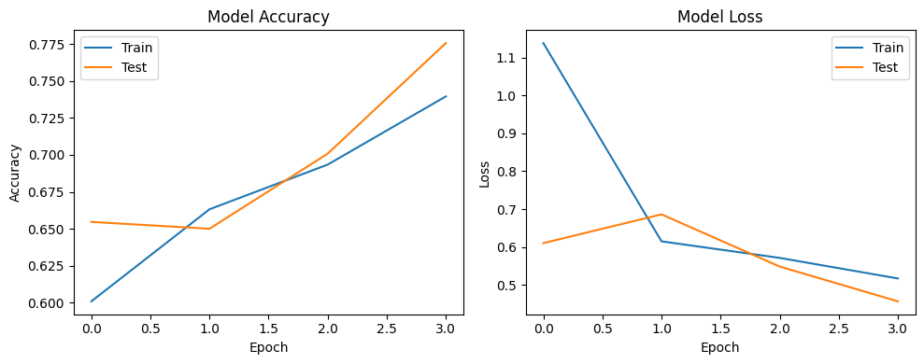

Test Accuracy = 0.7756
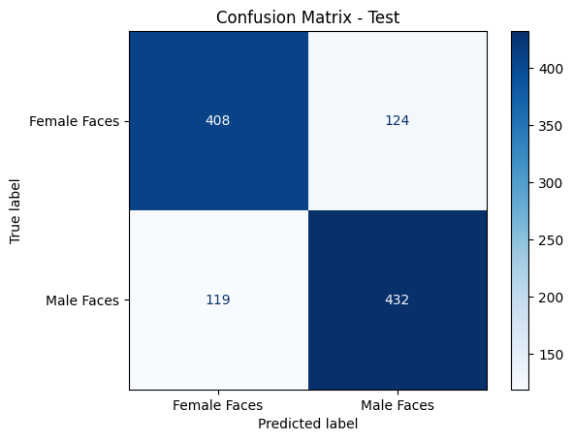

Classification Report:

precision recall f1-score support

Female Faces 0.77 0.77 0.77 532
Male Faces 0.78 0.78 0.78 551

accuracy 0.78 1083
macro avg 0.78 0.78 0.78 1083
weighted avg 0.78 0.78 0.78 1083

Test Accuracy = 0.7756

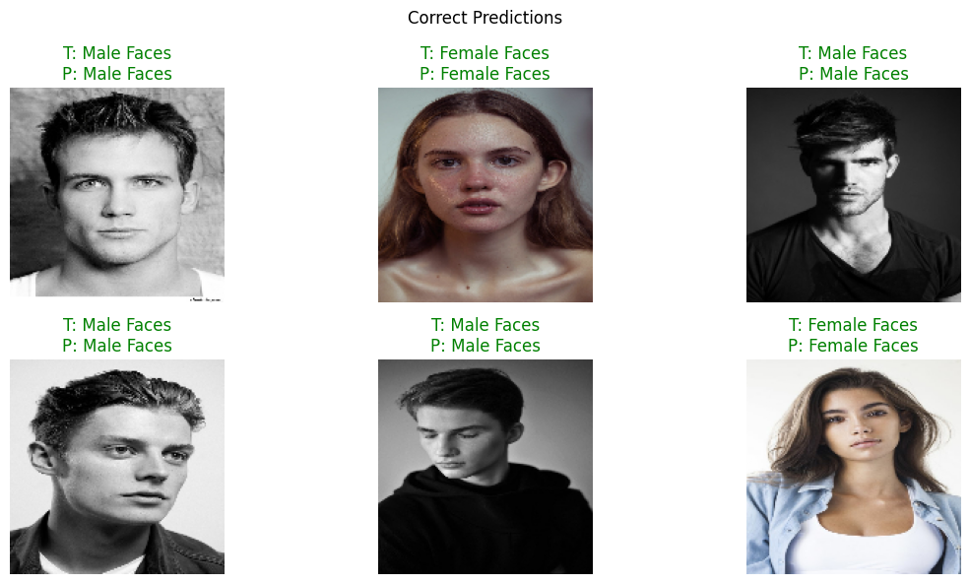
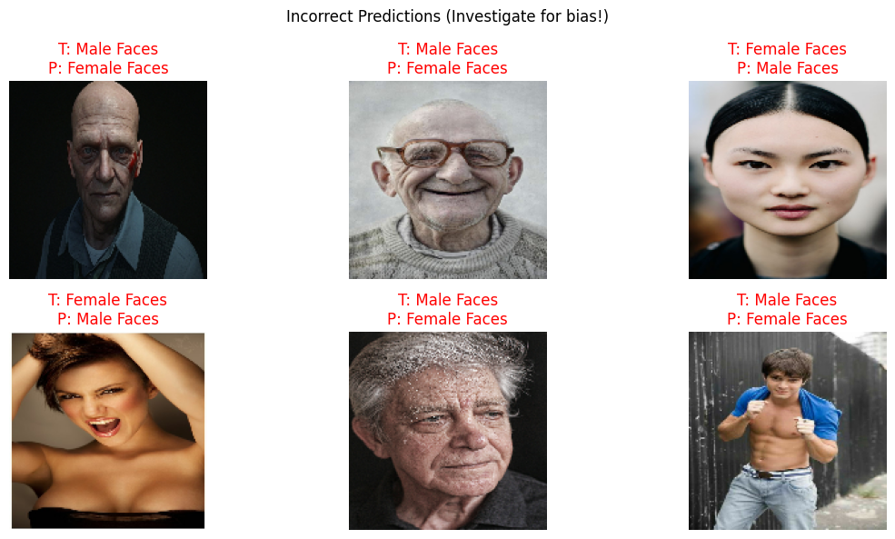

Appendix B: Model B
Learning rate = 0.001
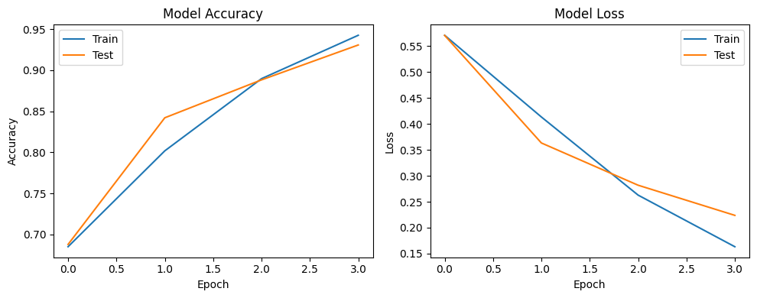
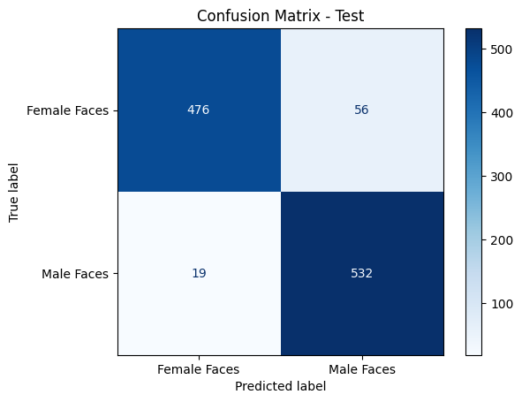
Classification Report:

precision recall f1-score support

Female Faces 0.96 0.89 0.93 532
Male Faces 0.90 0.97 0.93 551

accuracy 0.93 1083
macro avg 0.93 0.93 0.93 1083
weighted avg 0.93 0.93 0.93 1083

Test Accuracy: 0.9307

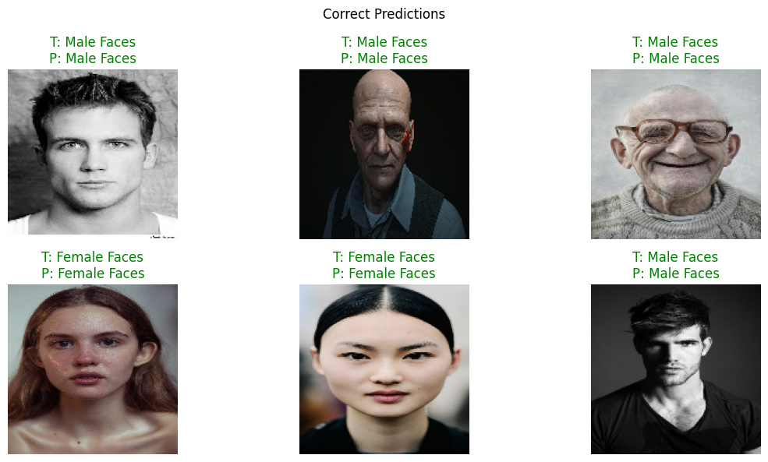
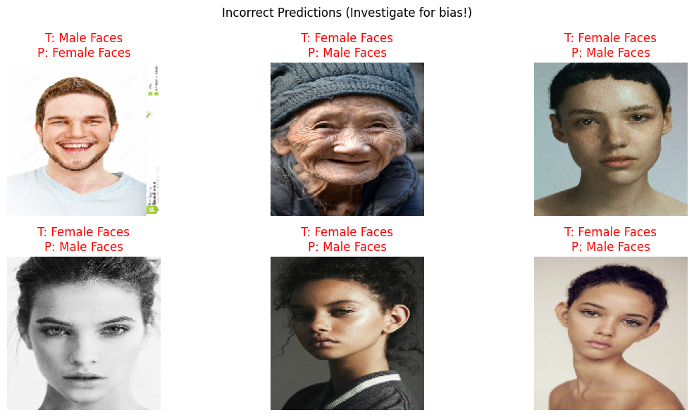

Appendix C
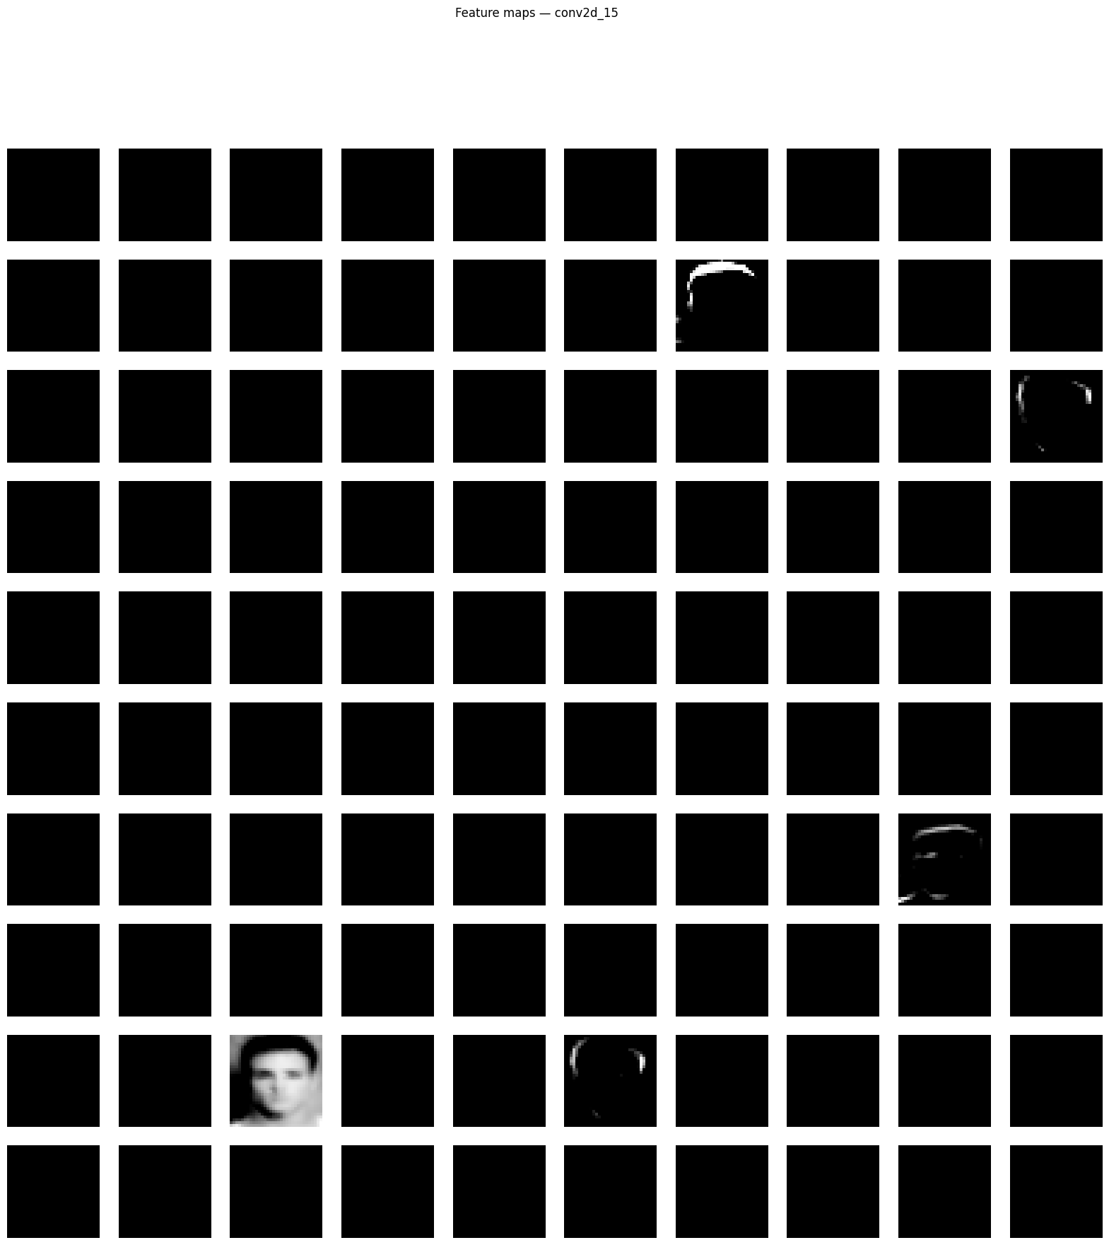

Appendix
Page:
Introduction ………………………………………………………………………………….. 1
Background ………………………………………………………………………………….. 1-2
Dataset Overview ……………………………………………………………………………. 2
Methods ……………………………………………………………………………………… 2-3
Results ……………………………………………………………………………………….. 3-4
Discussion …………………………………………………………………………………… 4-5
Conclusion …………………………………………………………………………………… 6
References …………………………………………………………………………………… 7
Appendices A, B, C …………………………………………………………………………. 8-13

